**E-R Diagram For Shopping Store**

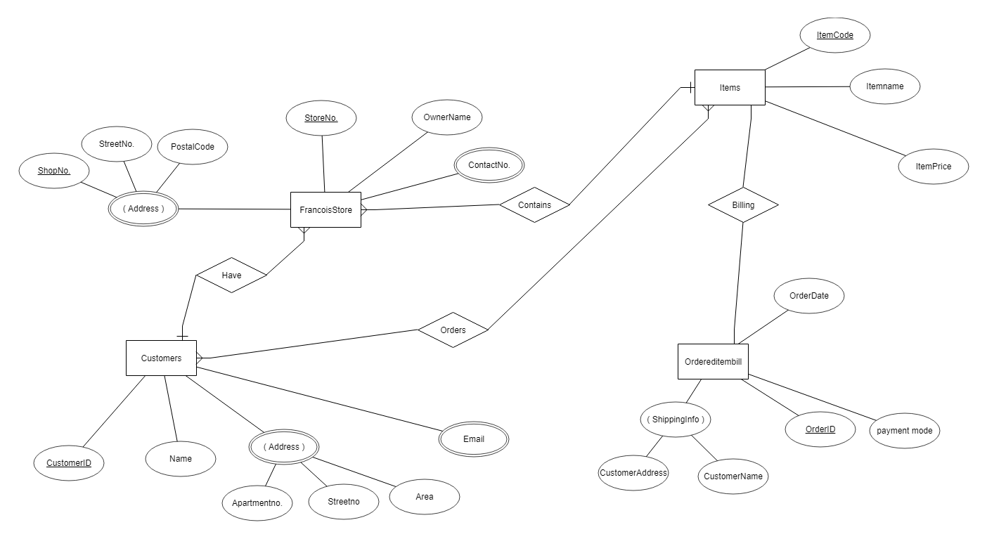

**List of Entities :**

Francois Store

Customers

Items

Ordereditembill

**List Of Attributes :**

**Francois Store :**

* StoreNo. (primary key)
* Owner Name
* ContactNo.(Multivalue)
* Address (Composite and Multivalue)

**Customers :**

* CustomerId (primary Key)
* Name
* Address (Multivalue and composite)
* Email (Multivalue)

**Items:**

* ItemCode (primary key)
* Itemname
* itemPrice

**Ordereditembill**

* OrderId (primary key)
* Orderdate
* PaymentMode
* ShippingInfo (Composite)

**Relationship :**

* Francois Grocery store has customers
* Customers order items
* Items are billed